Asynchronous Calls

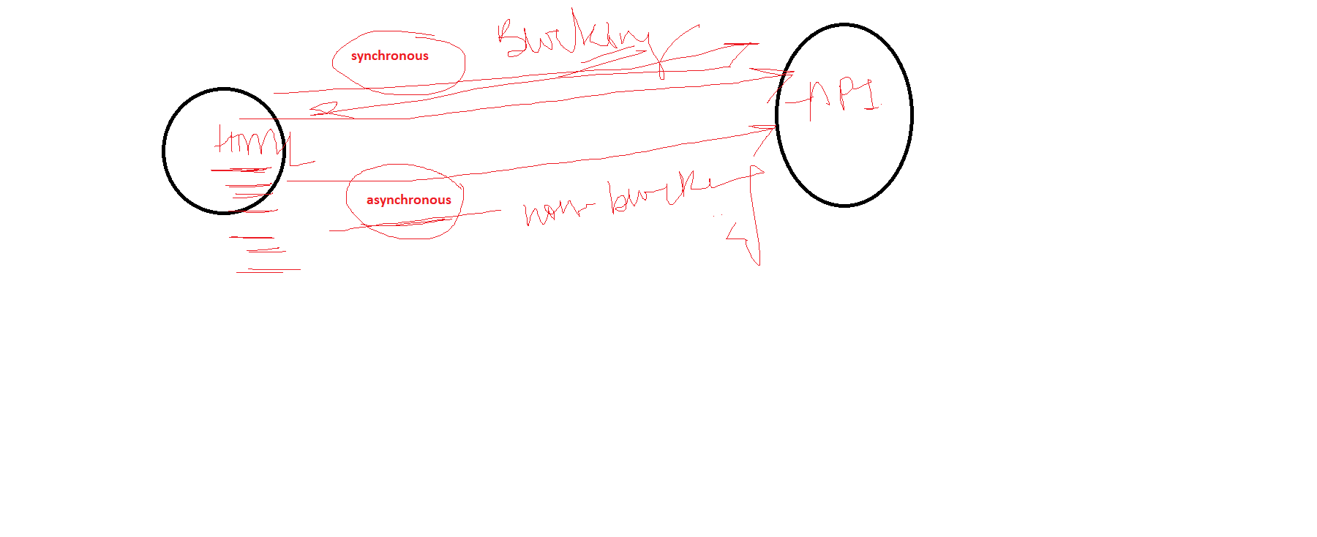

Callback Methods

It is method in which we pass some other method as a argument

